**Assignment 12**

**Obtain probability distribution of x, where x is number of spots showing when a six-sided symmetric die is rolled. Simulate random samples of sizes, 40, 70 and 100 respectively and verify frequency interpretation of probability**

sample1 = sample(c(1:6),size=40,replace=TRUE)

plot(sample1,col=sample1)

barplot(table(sample1),col=c('red','green','blue','gray','black',7),xlab='Values of dice',ylab='Frequency of Values')

print("Probability distribution:")

print(table(sample1)/40)

sample2 = sample(c(1:6),size=70,replace=TRUE)

plot(sample2,col=sample2)

barplot(table(sample2),col=c('red','green','blue','gray','black',7),xlab='Values of dice',ylab='Frequency of Values')

print("Probability distribution:")

print(table(sample2)/70)

sample3 = sample(c(1:6),size=100,replace=TRUE)

plot(sample3,col=sample3)

barplot(table(sample3),col=c('red','green','blue','gray','black',7),xlab='Values of dice',ylab='Frequency of Values')

print("Probability distribution:")

print(table(sample3)/100)

**Output**

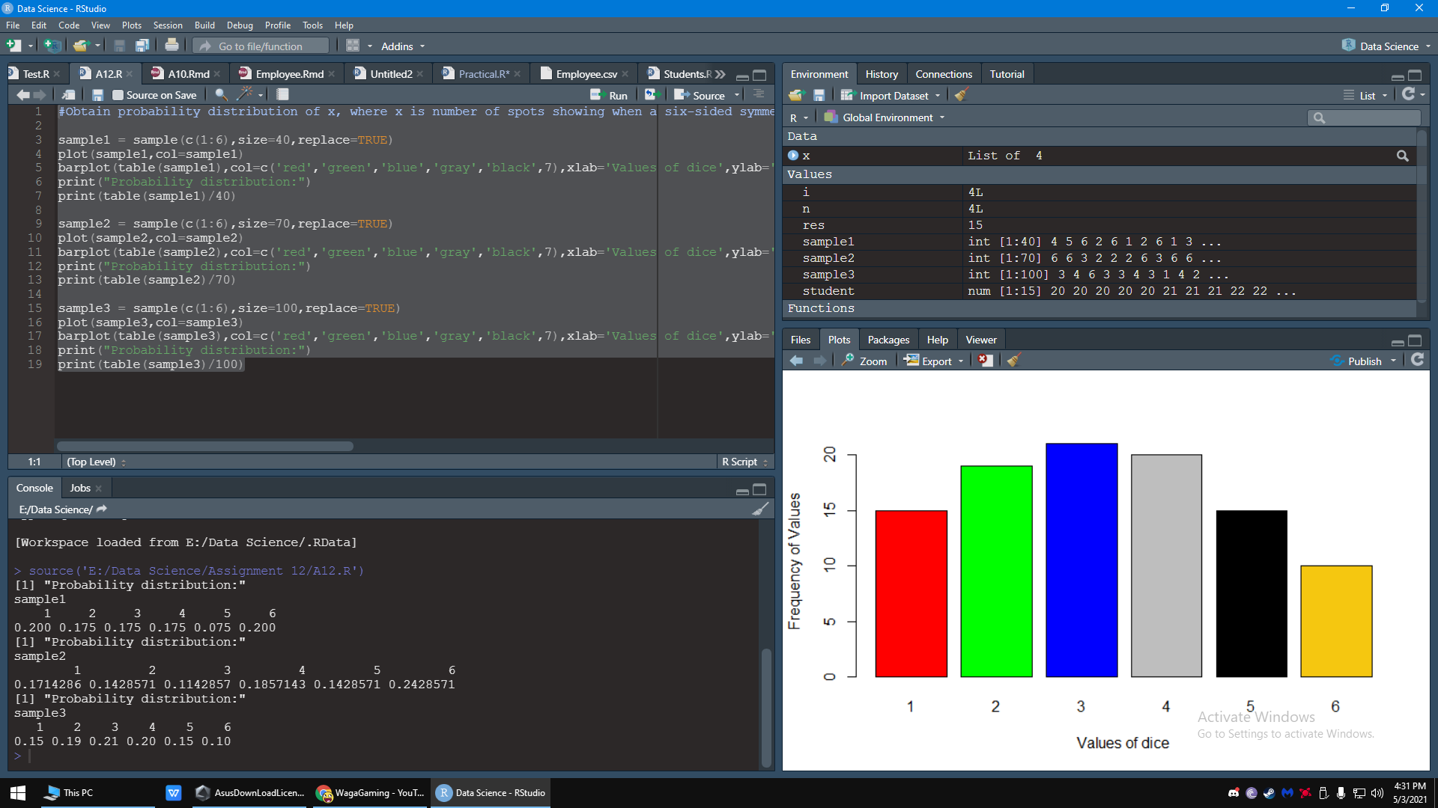

**Graphs**

**Sample 1**

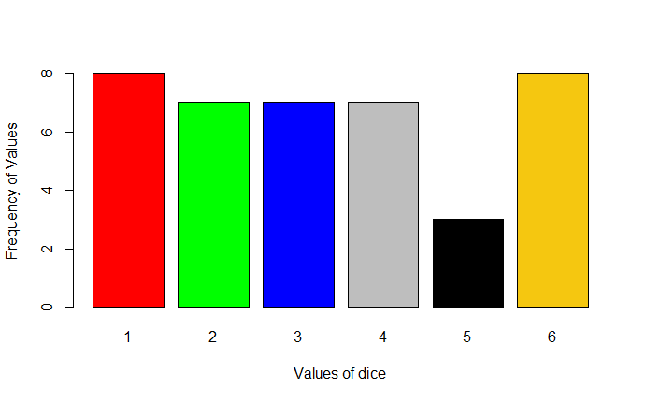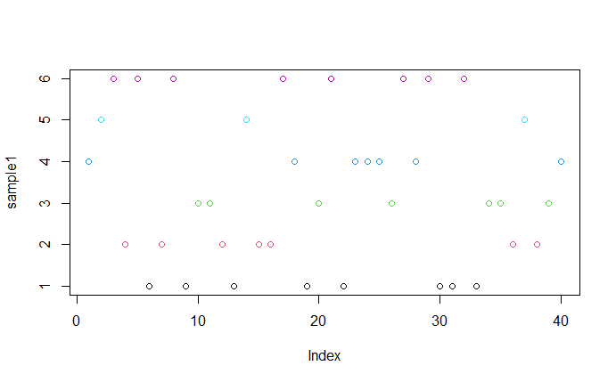

**Sample 2**

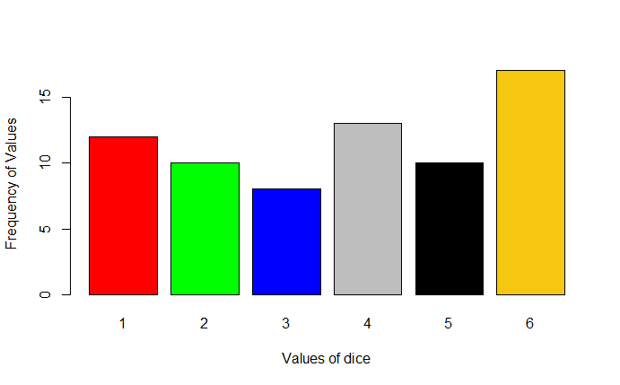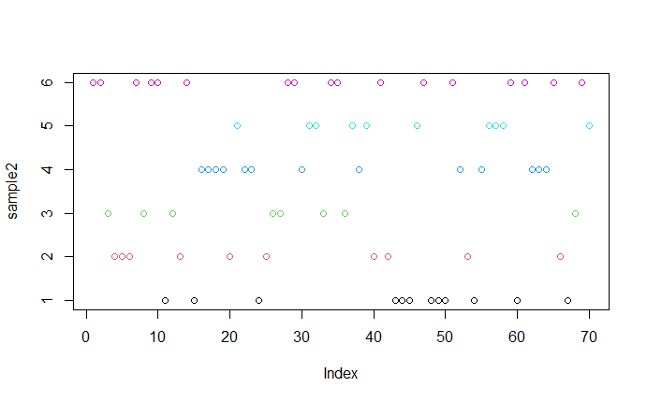

**Sample 3**

